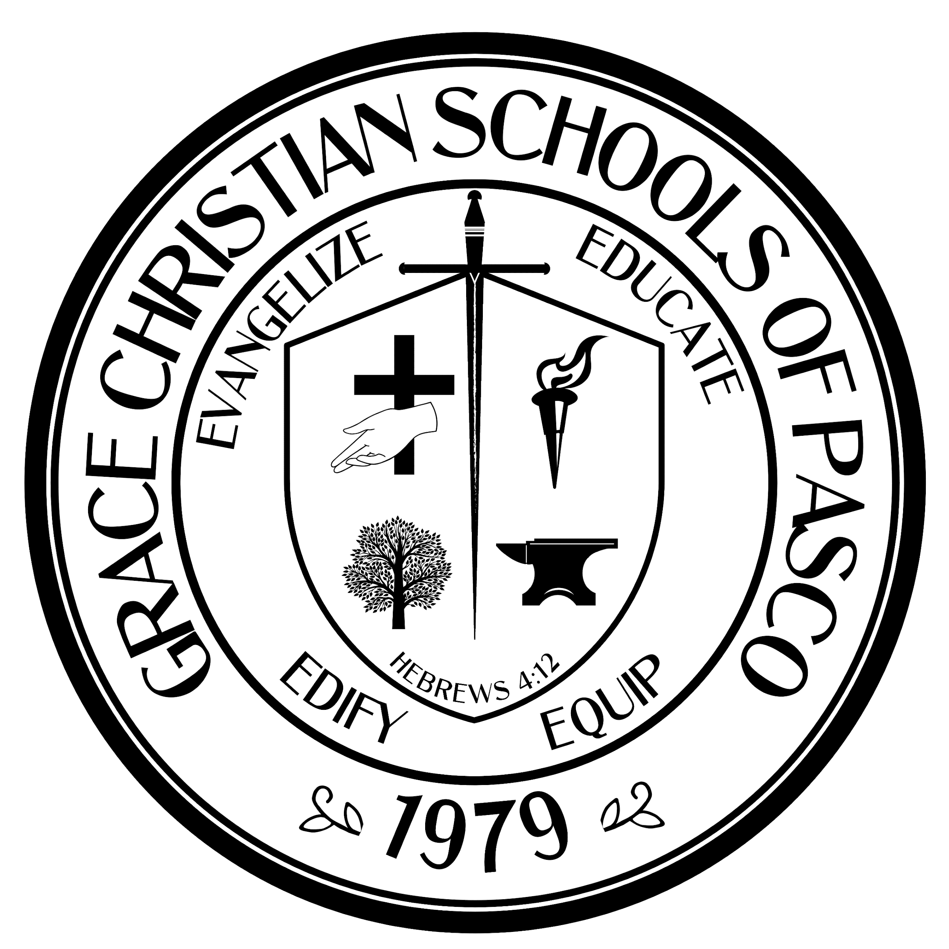
THE SWORDSMAN NEWSLETTER
12 December 2025

GRACE CHRISTIAN SCHOOL
A Ministry of Grace Bible Church
9403 Scot Street, Hudson, FL 34669
www.gracechristianschoolfl.com
Dec 2025

“Be of good courage, and He shall strengthen your heart, all you who hope in the Lord.”
Psalm 31:24 (NKJV)
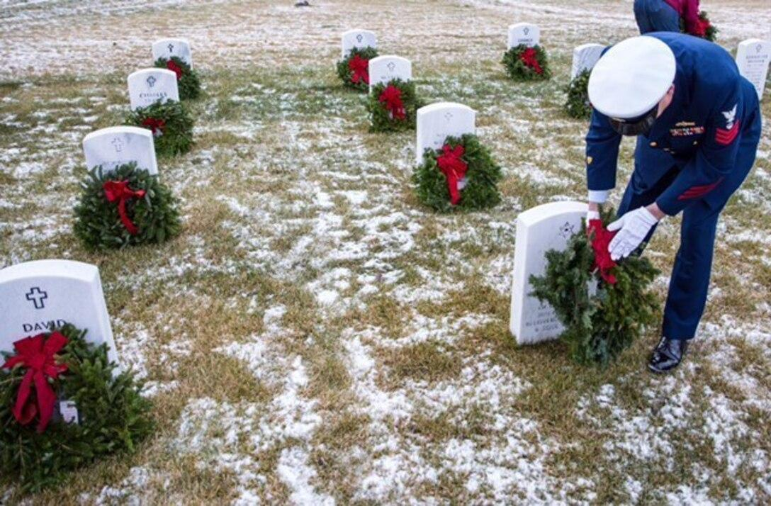



**No School – Christmas Break – No School**

December 22 - January 5
(return to school on 1/6/26)
Christmas Store - Open During Student Lunches & Christmas Program
Sunday | Monday | Tuesday | Wednesday | Thursday | Friday | Saturday
 | 1 | 2 | 3 | 4 | 5 | 6
 |  |  | 11th Grade  Community Service  First Baptist of Hudson  FOOD BANK  8:30 - 2:00 | Chapel  Pastor Dean  6th - 12th @ 8:50AM  K - 5th @ 9:45 AM  Students Recite  John 14:6 | Dress Down $$  Senior Fundraiser
7 | 8 | 9 | 10 | Chapel 11 | 12 | 13
 |  | GBC School Committee Meeting  7:00 PM |  | Pensacola Christian College  6th - 12th @ 8:50AM  Pastor Sean  K - 5th @ 9:45 AM | Senior Fundraiser  (Hot Cocoa @ lunch)  GCS  Christmas Program  7:00 PM
14 | 15 | 16 | 17 | Chapel 18 | 19 | 20
 | End of Term Exams  Grades 9-12 | End of Term Exams  Grades 9-12 | 1st Semester  Community Service Hours Due  End of Term Exams  Grades 9-12 | Mr. Glen Pratt  Christmas Stories  (with Popcorn)  6th - 12th @ 8:50AM  K - 5th @ 9:45 AM  Students Recite  Romans 8:38-39 | Tampa Zoo-Field Trip  2nd & 3rd Grade  (8:15 AM - 2:30 PM)  Spirit Day  Ugly Sweater | Wreaths Across America  6502 SW 102nd Ave, Bushnell, 33513
21 | 22 | 23 | 24 | 25 | 26 | 27
 |  |  |  | ,Jesus!
28 | 29 | 30 | 31 | 1 | 2 | 3
* Class Competition (winning class chooses from ice cream social or pizza party) All family is welcome to attend any chapel services!!
Christmas Candy Collection for Foster Families*
December 1st - December 12th



Thank you to GCS Athletics’ Gold Level Sponsor!
RNR Tire Express 9218-9226 US-19, Port Richey, FL 34668 www.rnrtires.com

Thank you to GCS 2026 Yearbook Sponsors!

BEEF O BRADY’S - 8717-6 Little Rd., New Port Richey, FL 34654 www.beefobradys.com
Leo’s Barber Shop - 4110 Little Rd., New Port Richey, FL 34655 www.leosbarbershop.com
Nature Wood Floors - 13266 Byrd Dr., Suite 200, Odessa, FL 33556 www.naturewoodfloors.com
New Image Dermatology - 5534 Gulf Dr., Suite 1 New Port Richey, FL 34667 www.newimagederm.com
REMAX Champions - 11541 Trinity Blvd., Trinity, FL 34655 www.RemaxChampions.com
Coast Buick GMC - 10133 US 19 Port Richey, FL 34668 www.coastbuickgmc.com
HENGESBACH & HENGESBACH - Attorneys and Counselors at Law
Hernando, Citrus, & Pasco FL www.naturecoastlaw.com
FLORIDA UTILITY SERVICES 1. LLC - 5911 Trouble Creek Road, New Port Richey, FL 34652 Mike@fus1llc.com
Action Towing Inc. of Tampa - 8629 Bolton Ave. Hudson, FL 34667 www.actiontowingtampa.com
Pro Auto Care- 1207 Sheldon Road, Tampa, FL 33626 www.proautocareinc.com
Pro Auto Collision- 1207 Sheldon Road, Tampa, FL 33626

Calendar Events…
12-1 to 12-12 Begin Candy Collection for Foster Care Christmas
12-3-25 (Wed) Community service 11 grade work at Food Bank at 1st Baptist of Hudson
12-4-25 (Thur) Chapel: Students Recite John 14:6. Pastor Dean Pratt
12-5-25 (Fri) Senior Dress down Day
12-8 to 12-12 School Christmas Store
12-9-25 (Tues) School Committee meeting 7:00pm
12-11-25 (Thur) Chapel: Pensacola Christian College (6-12 grade) | Pastor Sean Maniscalco
12-12-25 (Fri) K-12 Christmas program 7:00pm | Senior Fundraiser @ lunch (hot cocoa)
12-13-25 (Sat) Wreaths Across America, Bushnell (Student Council)
12-15 to 12-19-25 Monday-Friday End of Semester Exams (Grades 9-12)
12-17-25 (Wed) 1st Semester Community Service Hours due (Grades 9-12)
12-18-25 (Thur) Chapel: Students Recite Romans 8:38-39 | Pastor Glen Pratt
12-19-25 (Fri) Field Trip to Tampa Zoo 2nd & 3rd Grade | Spirit Day - Ugly Sweater, Christmas Themed
Students clean cubbies and lockers and take items home | End of 1st Sem., Last day of Finals
12-22-25 to 1-5-26 *NO SCHOOL* Christmas Vacation (return to school on Tues., Jan. 6th, 2026

Sporting Events…
12-1-25 (Mon) Home vs Elfers JVB @ 4:30
12-8-25 (Mon) Away @ HOPE
12-19-25 (Fri) Home vs Oldsmar JVG @ 4:30 | JCB to follow

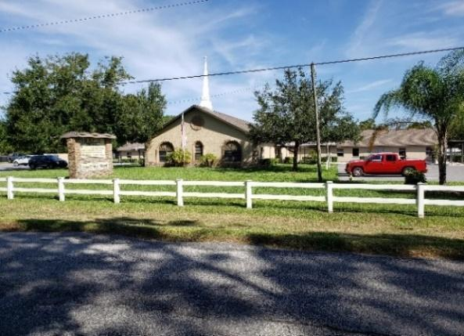
GRACE BIBLE CHURCH

- Kids’ Club meets on Tuesday evenings in the gym 6:30-8:00 pm. This is for students in kindergarten through 5th Grade.
*Note: WHEN THERE IS NO SCHOOL, KIDS’ CLUB WILL NOT BE HELD.
Upcoming Events:

- AfterShock (JH/SH Youth Group) meets in the gym every Wednesday evening for students in grades 6-12 from 6:00-8:00 PM. Come out and learn how you can make a difference for Jesus Christ in the world we live in!
Upcoming Events:

HOURS : School Office: M-F 7:30-4:00 / Business Office: M-F 7:30-4:00 / Church Office: T, W, TH 9:00-4:00
GRACE BIBLE CHURCH AND GRACE CHRISTIAN SCHOOLS of PASCO IS A TOBACCO & VAPE FREE CAMPUS

