SPORTS PROGRAMS AT GRACE CHRISTIAN SCHOOL



VOLLEYBALL – GR. 6-12

JV & Varsity



BASKETBALL – GR. 6-12

JV – Boys & Girls

Varsity – Boys & Girls

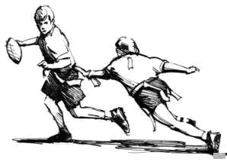

FLAG FOOTBALL – gr. 6-12



SOCCER – Gr. 6-12

JV & Varsity



CROSS COUNTRY – GR. 6-12

Varsity



GOLF – GR. 6-12

Varsity



BOOSTER CLUB BASKETBALL GR. 3-5